EXERCISES - CONDITIONAL LOGIC
Ex1. Write a program to accepts an integer n from the user then check whether n is an even or odd number.
If n is an even number, print the following line:


If n is an odd number, print the following line:


-----
Program:
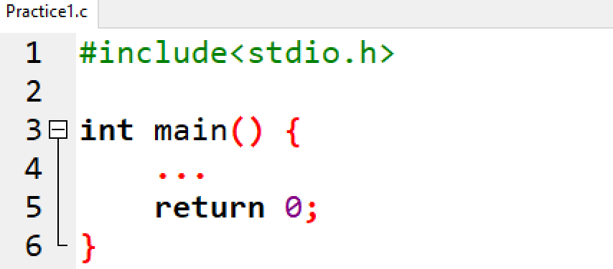

EX2. Write a program that accepts an integer n from the user then checks the following conditions:
If n is a positive integer, print the following line on the screen:
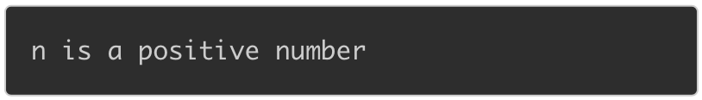

If n is a negative integer, print the following line on the screen:


If n is equal to 0, print the following line on the screen:


-----
Program:

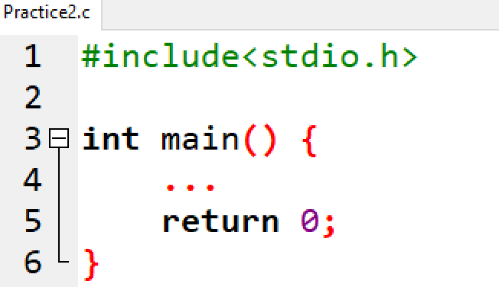

EX3. Write a program to read two integers a and b then check whether both a and b are not equal to zero or not.

If two values are not equal to 0, print the following line on the screen:
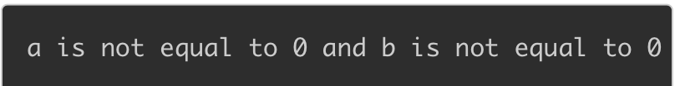

If a or b is equal to 0, print the following line on the screen:


-----
Program:

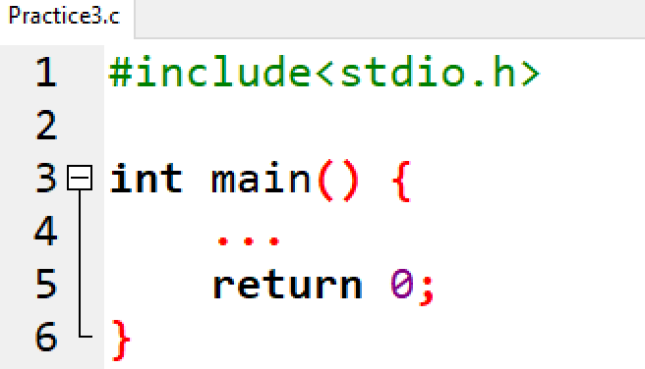

EX4. Write a program that accepts three integers from the user and prints the biggest number among them on the screen.
For example, if you enter three numbers as below:


When the code is compiled and executed, it produces the following result:


If you enter:


When the code is compiled and executed, it produces the following result:


-----
Program:
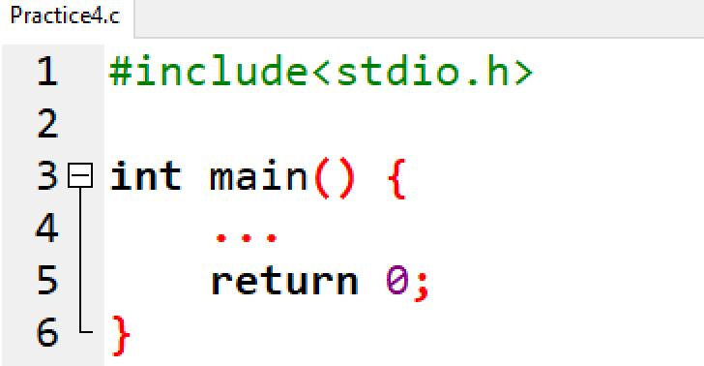

EX5. Write a program that accept an integer a then check whether a is in the range [10, 100] or not.
If a is in the range [10, 100], print the following line on the screen:


If a is not in the range, print the following line on the screen:


where {P} is the value of a.

-----
Program:

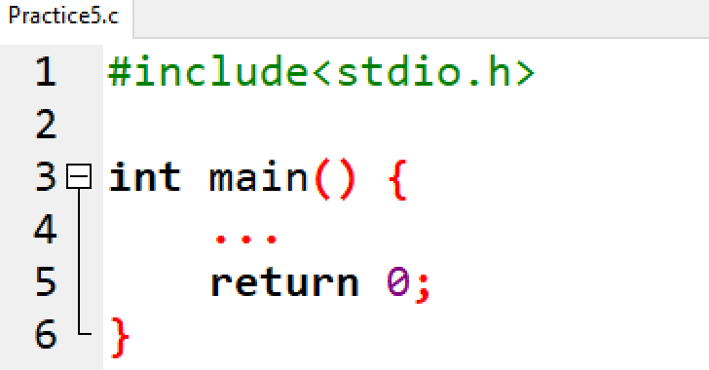

EX6. Write a program that accepts the test score of a student (knowing that the valid score is greater than or equal to 0 and less than or equal to 10) and checks whether the entered score is valid or not.
If the score is valid, print the following line on the screen:


If the score is invalid, print the following line on the screen:


-----
Program:

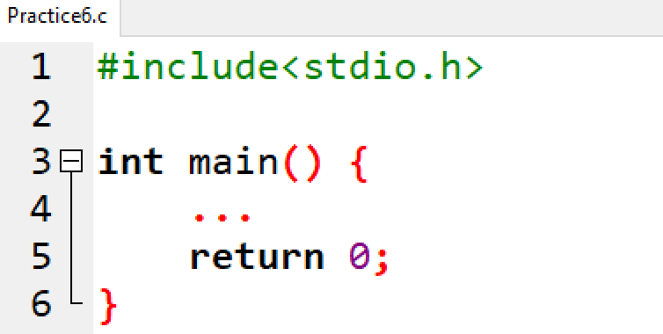

EX7. Given 2 integer variables a and b and a character variable c knowing that c is one of 4 characters '+', '-', '*', '/'. Write a program to read 3 variables a, b and c then display the result of expression when applying the operation c on a and b.
For example, if a = 7, c = '+', b = 9, enter the following line:
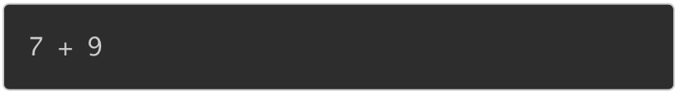

When the code is compiled and executed, it produces the following result:


-----
Program:

